STATIC ROUTING:
Topology Pic:
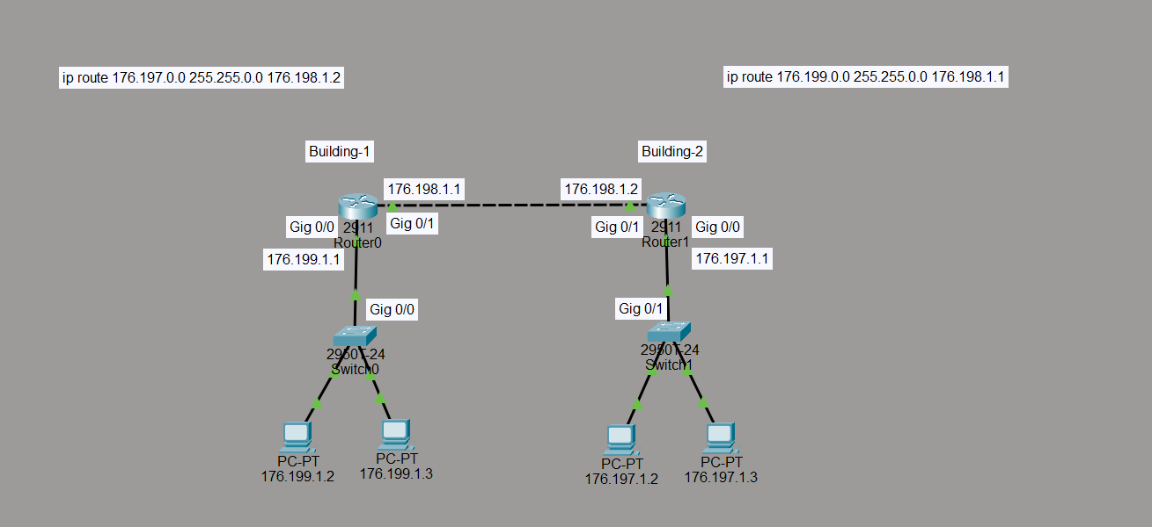

Building-1
Router 0:
Information:
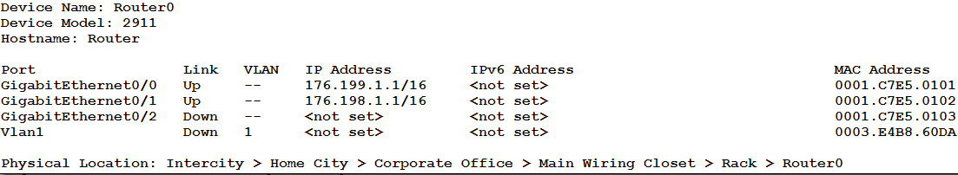
Configuration:
Router>en
Router#show run
Building configuration...

Current configuration : 761 bytes
!
version 15.1
no service timestamps log datetime msec
no service timestamps debug datetime msec
no service password-encryption
!
hostname Router
ip cef
no ipv6 cef
!
license udi pid CISCO2911/K9 sn FTX152493A0-
!
spanning-tree mode pvst
!
interface GigabitEthernet0/0
ip address 176.199.1.1 255.255.0.0
duplex auto
speed auto
!
interface GigabitEthernet0/1
ip address 176.198.1.1 255.255.0.0
duplex auto
speed auto
!
interface GigabitEthernet0/2
no ip address
duplex auto
speed auto
shutdown
!
interface Vlan1
no ip address
shutdown
!
ip classless
ip route 176.197.0.0 255.255.0.0 176.198.1.2
!
ip flow-export version 9
!
line con 0
!
line aux 0
!
line vty 0 4
login
!end
Switch0 → 2960-24 :
- PC0 → 176.199.1.2
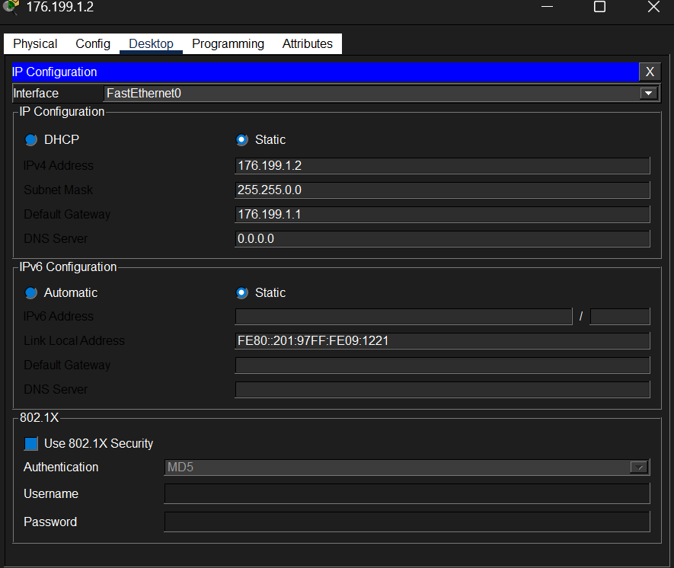
- PC1 → 176.199.1.3
- 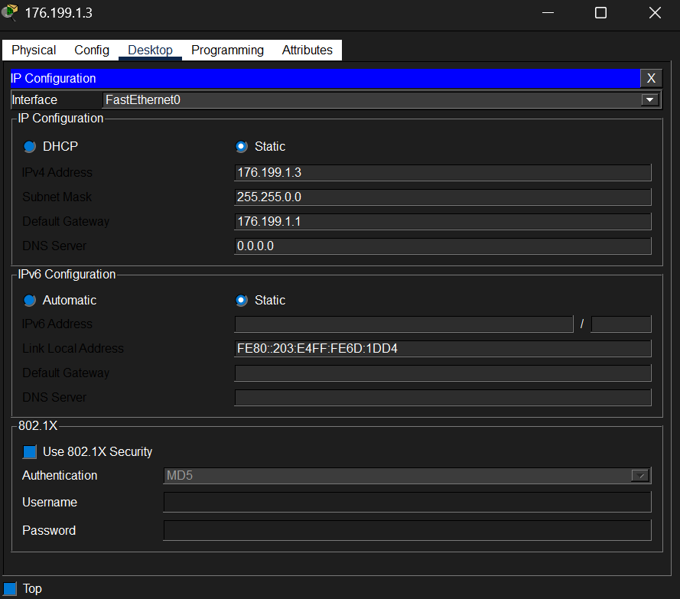

Building-2:
Router 1:
Information:
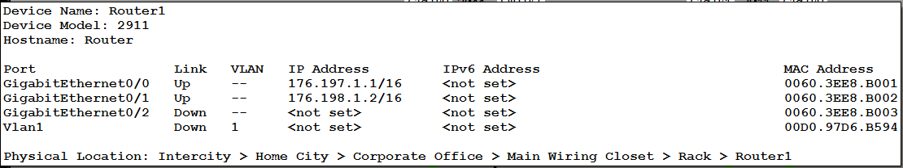
Configuration:
Router>en
Router#show run
Building configuration...
Current configuration : 761 bytes
!
version 15.1
no service timestamps log datetime msec
no service timestamps debug datetime msec
no service password-encryption
!
hostname Router
ip cef
no ipv6 cef
!
license udi pid CISCO2911/K9 sn FTX1524DID4-
!
spanning-tree mode pvst
!
!
interface GigabitEthernet0/0
ip address 176.197.1.1 255.255.0.0
duplex auto
speed auto
!
interface GigabitEthernet0/1
ip address 176.198.1.2 255.255.0.0
duplex auto
speed auto
!
interface GigabitEthernet0/2
no ip address
duplex auto
speed auto
shutdown
!
interface Vlan1
no ip address
shutdown
!
ip classless
ip route 176.199.0.0 255.255.0.0 176.198.1.1
!
ip flow-export version 9
!
line con 0
!
line aux 0
!
line vty 0 4
login
end
Switch1 → 2960-24:
- PC2 → 176.197.1.2
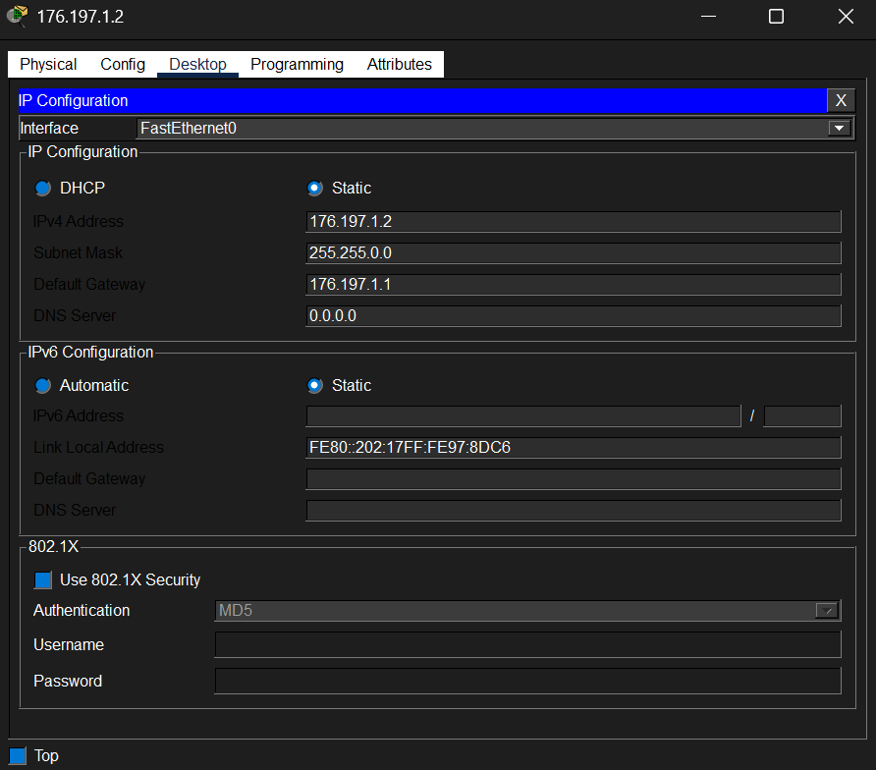
- PC3 → 176.197.1.3
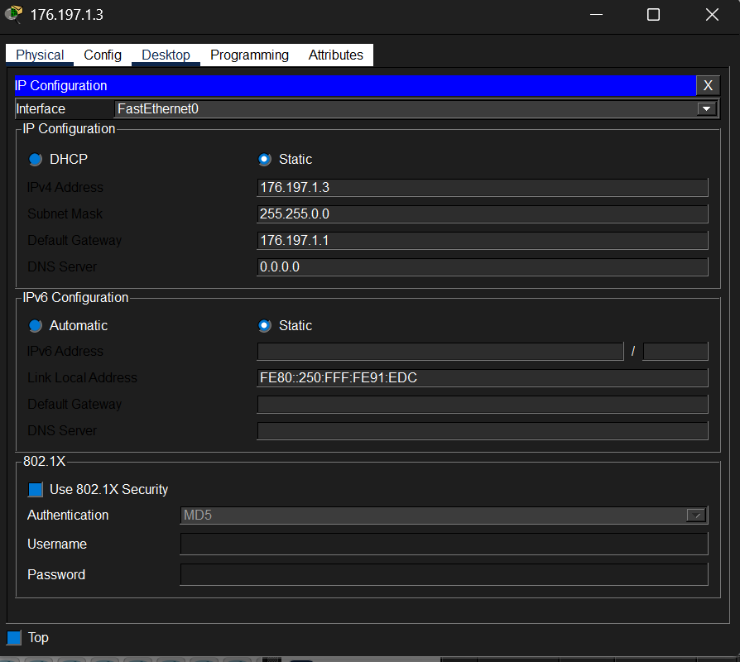
PING Command:
Building 1 with both pc of building 2:
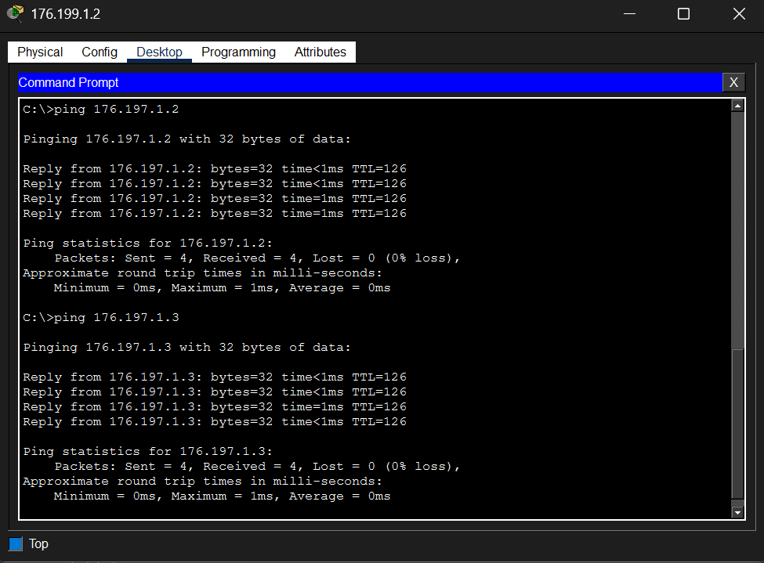
Building 2 with both pc of building 1:
